GetAdminTradeInfo API
- Added New API Request as GetAdminTradeInfo for IBT Group_Admin.
- In User Management select Category as Group Admin & Tick on IBT check box while creating new Group_Admin / Modifying Existing Group_Admin.
- On Server set "EnableAdminRestAPI" flag as true in IBT section of CTCLManager.ini file.
- For this New REST API, METHOD is POST

- Following is the GetAdminTradeInfo details Request
URL : http://192.168.209.244:3333/getAdminTradeInfo
In this URL 192.168.209.244 is Server IP where Iris component is started & 3333 is REST_API_PORT which is set in IBT section of CTCLManager.ini file.
REQUEST BODY :
{
"request":
{"data":
{
"gscid": "ADMIN1",
"product":"1",
"market_id":"1",
"tradeSymbol":"INFY"
},
"response_format": "json",
"request_type": "subscribe",
"streaming_type": "GetAdminTradeInfo"
}
}

- In above request body, “ gscid “ is Mandatory field
- In above request body, “ product “, “ market_id ” & “ tradeSymbol “ is the Optional fields.
- 'gscid' should be the the gscid of 'Group_Admin'.
- Group_Admin (gscid) type should be "3" in DB >> Clients table.

Following are Product Type as per Category
- "product" : "0" i.e. DELIVERY
- "product" : "1" i.e. INTRADAY
- "product" : "2" i.e. MTF
- "product" : "3" i.e. TNC
- "product" : "4" i.e. COVER

- Following are Market ID as per Exchange & Segment
- "market_id" : "1" i.e. NSE EQ
- "market_id" : "2" i.e. NSE FO
- "market_id" : "3" i.e. NSE CD
- "market_id" : "4" i.e. BSE EQ
- "market_id" : "5" i.e. BSE FO
- "market_id" : "6" i.e. BSE CD
- "market_id" : "7" i.e. NCDEX
- "market_id" : "8" i.e. DGCX
- "market_id" : "9" i.e. MCX
- "market_id" : "10" i.e. CME
- "market_id" : "11" i.e. BNX
- "market_id" : "12" i.e. NNX
- "market_id" : "13" i.e. MCXSXCD
- "market_id" : "14" i.e. NOFS
- "market_id" : "15" i.e. NSE SLBM
- "market_id" : "16" i.e. NSE COM
- "market_id" : "17" i.e. BSE COM

- Following are example of GetAdminTradeInfo API request combination to fetch Trades data from IBT Group Admin
- Gscid only i.e. ADMIN1
In this API Request, All Exchanges & Segment Trades get fetch, which is display on IBT Group Admin Trade (F8) window.

REQUEST BODY :
{
"request":
{"data":
{
"gscid": "ADMIN1"
},
"response_format": "json",
"request_type": "subscribe",
"streaming_type": "GetAdminTradeInfo"
}
}
- After executing above GetAdminTradeInfo API request below response get display in Response body.
{
"response": {
"appID": "bc90bb525bc9739a9595bb9e176dab17",
"data": {
"trades": [
{
"ExpiryDate": "23AUG2024",
"OptionType": "CE",
"Price": 1.5,
"Product": 0,
"StrikePrice": 82.75,
"cAccountNumber": "RET12",
"cGreekClientId": "RAHUL",
"iBuySell": 2,
"iProCli": 1,
"isinNumber": "",
"lFillNumber": 780,
"lFillQuantity": 1,
"market_id": 6,
"series": "OPTCUR",
"symbol": "USDINR",
"tradeDateTime": "2024-08-20 17:44:03"
},
"infoID": "0",
"serverTime": 1724231784,
"streaming_type": "GetAdminTradeInfo",
"svcName": "GetADMINTradeInfo"
}
}
- Gscid & product i.e. ADMIN1 & 0
In this API Request, Only Product Type Delivery Trades for All Exchanges & Segment get fetch, which is display on IBT Group Admin Trade (F8) window.

REQUEST BODY :
{
"request":
{"data":
{
"gscid": "ADMIN1",
"product":"0"
},
"response_format": "json",
"request_type": "subscribe",
"streaming_type": "GetAdminTradeInfo"
}
}

- Gscid & market_id i.e. ADMIN1 & 1
In this API Request, Only NSE Exchange EQ Segment Trades get fetch, which is display on IBT Group Admin Trade (F8) window.

REQUEST BODY :
{
"request":
{"data":
{
"gscid": "ADMIN1",
"market_id":"1"
},
"response_format": "json",
"request_type": "subscribe",
"streaming_type": "GetAdminTradeInfo"
}
}

- Gscid & tradeSymbol i.e. ADMIN1 & INFY
In this API Request, Only INFY symbol Trades get fetch, which is display on IBT Group Admin Trade (F8) window.

REQUEST BODY :
{
"request":
{"data":
{
"gscid": "ADMIN1",
"tradeSymbol":"INFY"
},
"response_format": "json",
"request_type": "subscribe",
"streaming_type": "GetAdminTradeInfo"
}
}

- Gscid, product & market_id i.e. ADMIN1, 0 & 1
In this API Request, Product Type Delivery, NSE Exchanges & EQ Segment Trades get fetch, which is display on IBT Group Admin Trade (F8) window.

REQUEST BODY :
{
"request":
{"data":
{
"gscid": "ADMIN1",
"product":"0",
"market_id":"1"
},
"response_format": "json",
"request_type": "subscribe",
"streaming_type": "GetAdminTradeInfo"
}
}

- Gscid, product & tradeSymbol i.e. ADMIN1, 0 & INFY
In this API Request, Product Type Delivery & INFY symbol Trades get fetch, which is display on IBT Group Admin Trade (F8) window.

REQUEST BODY :
{
"request":
{"data":
{
"gscid": "ADMIN1",
"product":"0",
"tradeSymbol":"INFY"
},
"response_format": "json",
"request_type": "subscribe",
"streaming_type": "GetAdminTradeInfo"
}
}

- Gscid, market_id & tradeSymbol i.e. ADMIN1, 1 & INFY
In this API Request, NSE Exchanges & EQ Segment with only symbol INFY Trades get fetch, which is display on IBT Group Admin Trade (F8) window.

REQUEST BODY :
{
"request":
{"data":
{
"gscid": "ADMIN1",
"market_id":"1",
"tradeSymbol":"INFY"
},
"response_format": "json",
"request_type": "subscribe",
"streaming_type": "GetAdminTradeInfo"
}
}

- Gscid, product, market_id & tradeSymbol i.e. ADMIN1, 0, 1 & INFY
In this API Request, Product Type Delivery, NSE Exchanges, EQ Segment & INFY Symbol Trades get fetch, which is display on IBT Group Admin Trade (F8) window.

REQUEST BODY :
"request":
{"data":
{
"gscid": "ADMIN4",
"product":"0",
"market_id":"1",
"tradeSymbol":"INFY"
},
"response_format": "json",
"request_type": "subscribe",
"streaming_type": "GetAdminTradeInfo"
}
}

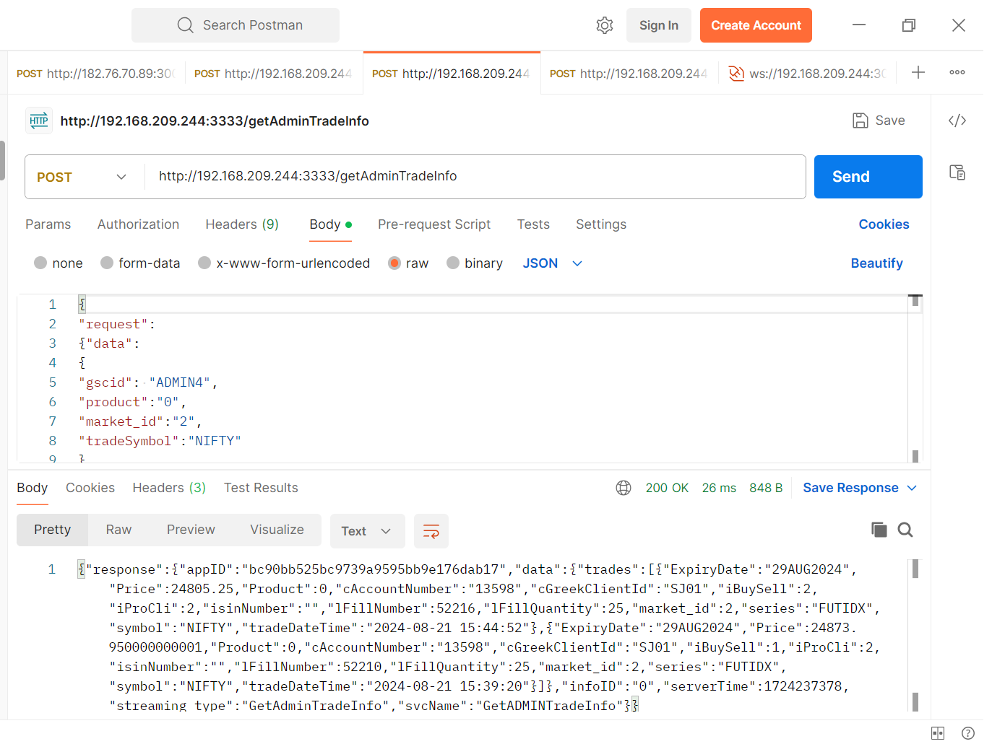

Web Socket

- For live trades on websocket we have to login Admin (With IBT) on Iris web socket.
- Connect to Iris Web Socket, using IBT Group Admin User and send login request.
- If login successful then you will receive live trades on same web socket.
- Following are step to create new login user for Web Socket & connect to Web Socket

URL : http://192.168.209.244:3333/jloginNew
In this URL 192.168.209.244 is Server IP where Iris component is started & 3333 is REST_API_PORT which is set in IBT section of CTCLManager.ini file.

REQUEST BODY :
{
"request": {
"data": {
"pan_dob": "01/01/1901",
"deviceId": "4f89423bab1280c9",
"gscid": "ADMIN1",
"deviceDetails": "",
"deviceType": "0",
"pass": "e6e061838856bf47e1de730719fb2609",
"transPass": "",
"userType": "Customer",
"brokerid": "1",
"passType": "0",
"version_no": "1.0.1.10",
"encryptionType": "1"
},
"svcName": "jloginNew",
"svcGroup": "Login"
}
}

- Executing above API Request following Response get display
"ClientCode": 6,
"ErrorCode": 0,
"Iris_IP": "192.168.209.244",
"Iris_Port": 3031, (3031 is Rest_webSocket_port which is set in IBT section of CTCLManager.ini)
"cCategory": "Group Admin",
"clientName": "ADMIN1",
"gscid": "ADMIN1",
"sessionId": "$2a$10$al6zKLZI85n86/PuaWrjfe",
"svcGroup": "Login",
"svcName": "jloginNew",

- Copy sessionId & paste in Web Socket connection request

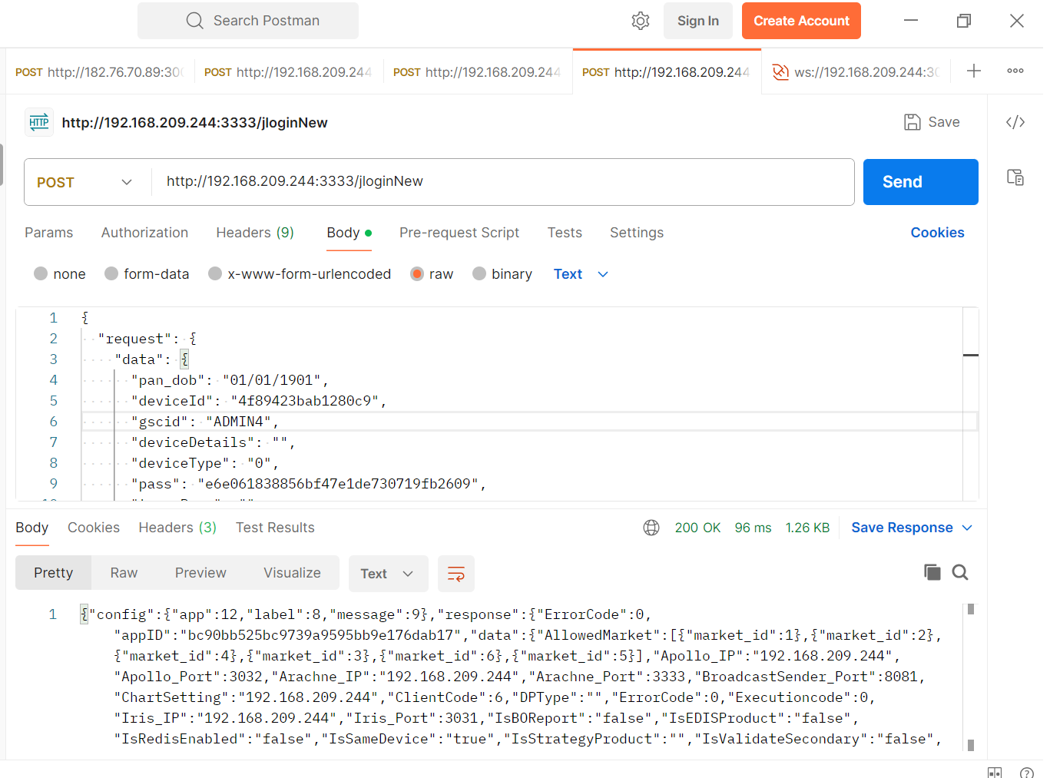

- Following is Web Socket connection request
URL : ws://192.168.209.244:3031

- Web Socket connection REQUEST BODY :
{
"request": {
"data": {
"gscid": "ADMIN1",
"gcid": "6",
"sessionId": "$2a$10$YCeXhNR5tWQVTnRB0pZQjO",
"device_type": "0"
},
"response_format": "json",
"request_type": "subscribe",
"streaming_type": "login"
}
}

- In above request mention gscid as ADMIN1 (IBT Group Admin), gcid as 6 (ClientCode i.e. 6)
- Copy & paste "sessionId": "$2a$10$YCeXhNR5tWQVTnRB0pZQjO", which is get from Web Socket jloginNew request.
- After Inserting all valid data in request click on Connect button then Web Socket is get Connected
- After Connecting Web Socket to Iris Components in Response Body Online Trades will get display.

- Example of Trade Response which is display in Web Socket Response body, mention below.
[
{
"response": {
"appID": "bc90bb525bc9739a9595bb9e176dab17",
"data": {
"trades": [
{
"ExpiryDate": "29AUG2024",
"Price": 24805.25,
"Product": 0,
"cAccountNumber": "13598",
"cGreekClientId": "SJ01",
"iBuySell": 2,
"iProCli": 2,
"isinNumber": "",
"lFillNumber": 52216,
"lFillQuantity": 25,
"market_id": 2,
"series": "FUTIDX",
"symbol": "NIFTY",
"tradeDateTime": "2024-08-21 15:44:52"
}
]
},
"infoID": "0",
"streaming_type": "GetAdminTradeInfo",
"svcName": "GetADMINTradeInfo"
}
}
]
